**Importing Arduino Library**

Corresponding libraries are needed to be added to Arduino Library in order to use the OLED display on WonderCam and the RGB LED module,

In the Lesson folder, file name U8g2.zip is the library file for OLED display and file name Adafruit_NeoPixel.zip is library file for RGB LED module.

Below is the a demo example of adding to the library.

1. Double click to open Arduino IDE.
2. On the menu, click “Sketch”, select “Include Library” and click “Add .ZIP Library”.

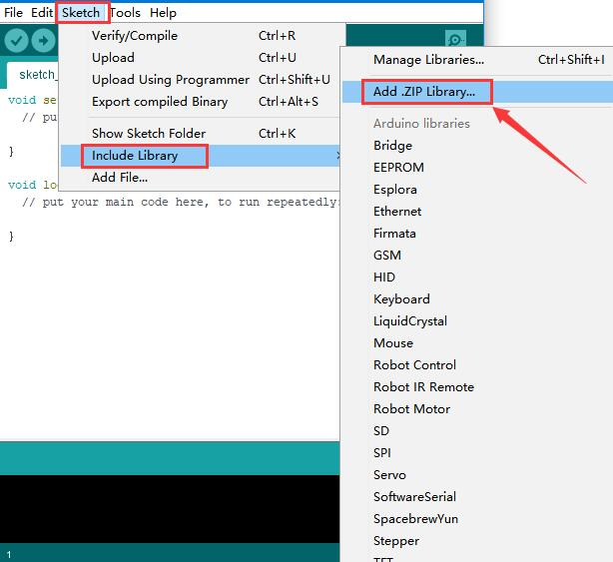

1. In this demo, locate U8g2.zip file and click “Open”.

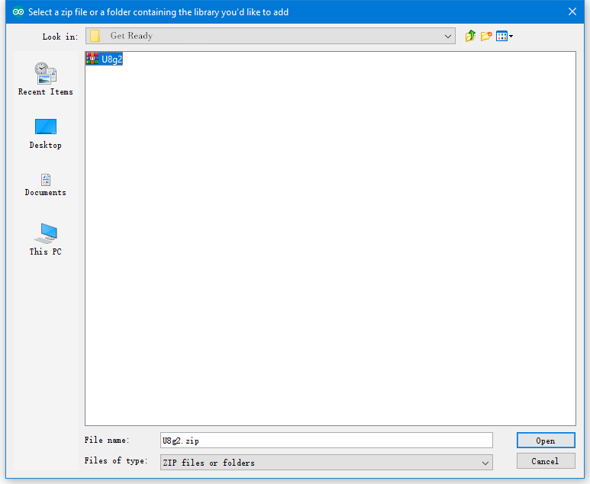

1. Return back to IDE main interface.Upon completion “Library Added” message will be shown.

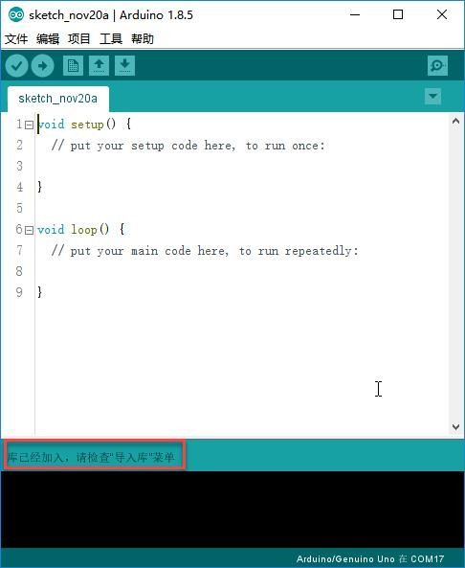

1. Continue to add in other Library if needed.